# **📘 Module 4: Mastering Large Language Models (LLMs)**

*(Self-Learning | Teaching | Interview-Ready Notes)*

## **🌍 Big Picture First (Why LLMs Matter)**

Large Language Models are the **brains behind AI systems** like:

* Chatbots (ChatGPT)
* Search assistants
* Document summarizers
* Code generators
* Translation systems
* AI tutors and copilots

They **understand, generate, summarize, translate, and reason with text** at a human-like level.

## **1️⃣ What is a Language Model?**

### **🔹 Simple Definition (Non-Technical)**

A **Language Model** is an AI system that:

**Predicts the next word** based on previous words.

Example:

"India is my ______"

Model predicts:

**country**

### **🔹 Slightly Technical Definition**

A **Language Model** learns the **probability distribution of word sequences**.

Formally:  
P(w1​,w2​,w3​,...,wn​)

Meaning:

“How likely is this sentence to occur in human language?”

### **🔹 How Does It Learn?**

It learns from **massive text data**:

* Books
* Wikipedia
* News
* Code repositories
* Websites

It **does NOT understand meaning like humans**,  
but **learns patterns extremely well**.

### **🔹 Evolution of Language Models**

| **Era** | **Model Type** | **Example** |
| --- | --- | --- |
| Old | Rule-based | Grammar rules |
| Early ML | N-grams | Word counting |
| Deep Learning | RNN, LSTM | Context aware |
| Modern | Transformers (LLMs) | GPT, BERT |

## **2️⃣ Scaling Laws of LLMs**

### **🔹 What Are Scaling Laws?**

**Scaling Laws** explain:

*As we increase model size, data, and compute — performance improves predictably.*

### **🔹 The 3 Scaling Dimensions**

| **Scale** | **What Increases** | **Effect** |
| --- | --- | --- |
| **Model Size** | Parameters (weights) | Better reasoning |
| **Data Size** | Training text | More knowledge |
| **Compute** | GPUs / TPUs | Faster & deeper learning |

### **🔹 Real-World Analogy**

📚 Student learning:

* More books → more knowledge
* More study time → better understanding
* Bigger brain capacity → better reasoning

### **🔹 Why Scaling Works**

Because **Transformers generalize well** when exposed to:

* Large data
* Long contexts
* Diverse tasks

### **🔹 But Scaling Has Limits**

❌ Expensive  
❌ Energy intensive  
❌ Diminishing returns  
❌ Data quality matters more than quantity

## **3️⃣ Architecture of Major LLMs (Core Section)**

## **🧠 Common Backbone: Transformer**

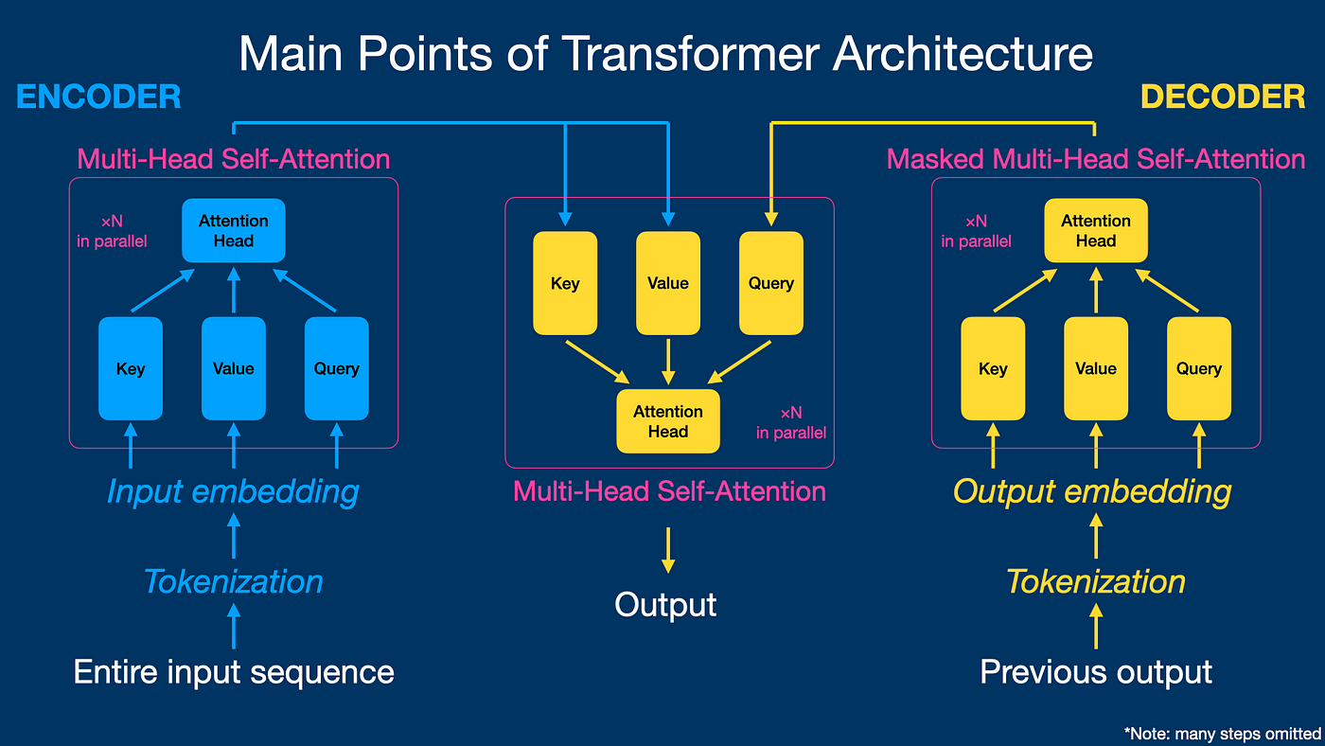

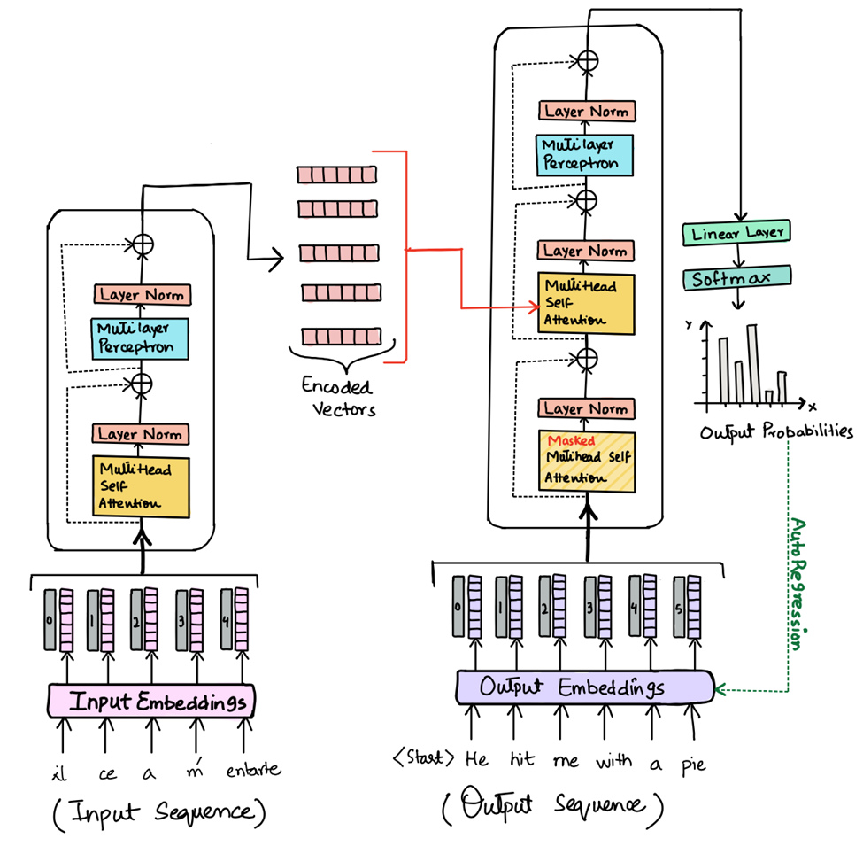

**Image**

### **🔹 Key Components**

* **Tokenization**
* **Embeddings**
* **Self-Attention**
* **Feed Forward Networks**
* **Layer Normalization**
* **Residual Connections**

## **🔹 Attention (Heart of LLMs)**

**Self-Attention answers:**

“Which words are important for this word?”

Example:

*“The animal didn’t cross the road because* ***it*** *was tired.”*

**“it” → animal**, not road.

## **3.1 GPT Architecture**

### **🔹 OpenAI GPT (Generative Pretrained Transformer)**

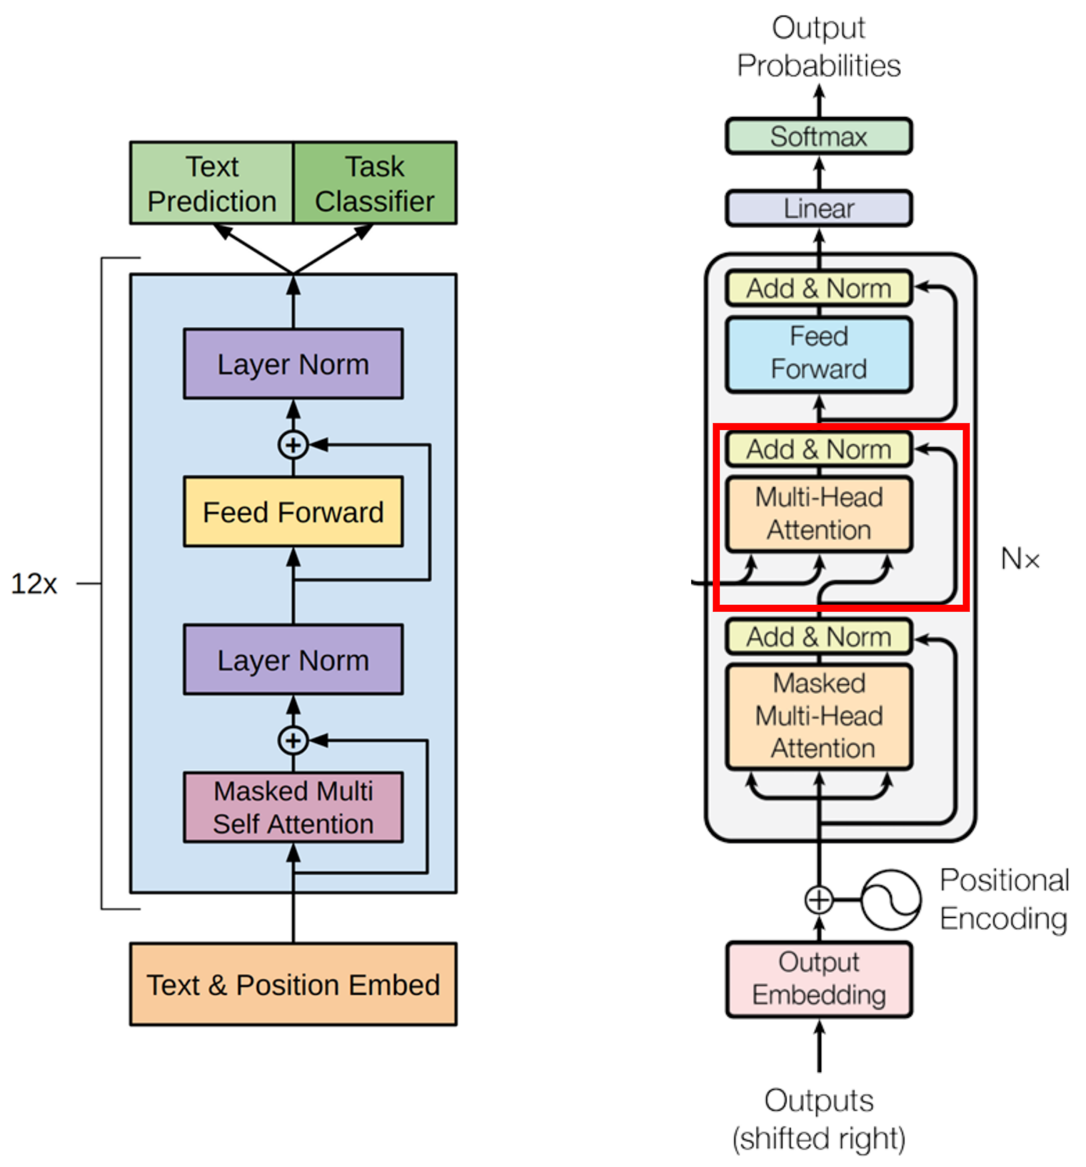

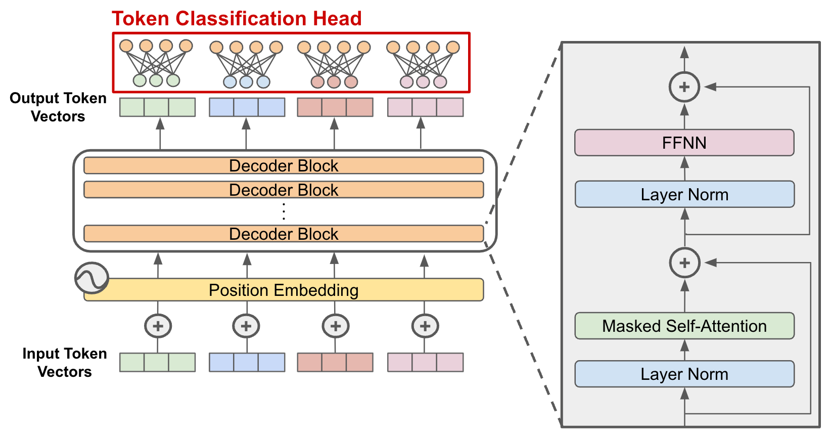

| **Aspect** | **GPT** |
| --- | --- |
| Architecture | Decoder-only |
| Training | Left-to-right |
| Best For | Text generation |
| Output | Free-flowing text |

### **🔹 How GPT Works**

1. Takes input tokens
2. Uses **masked self-attention**
3. Predicts **next token**
4. Repeats until completion

### **🔹 Use Cases**

* Chatbots
* Story writing
* Code generation
* Q&A systems

## **3.2 BERT Architecture**

### **🔹 Google BERT (Bidirectional Encoder Representations from Transformers)**

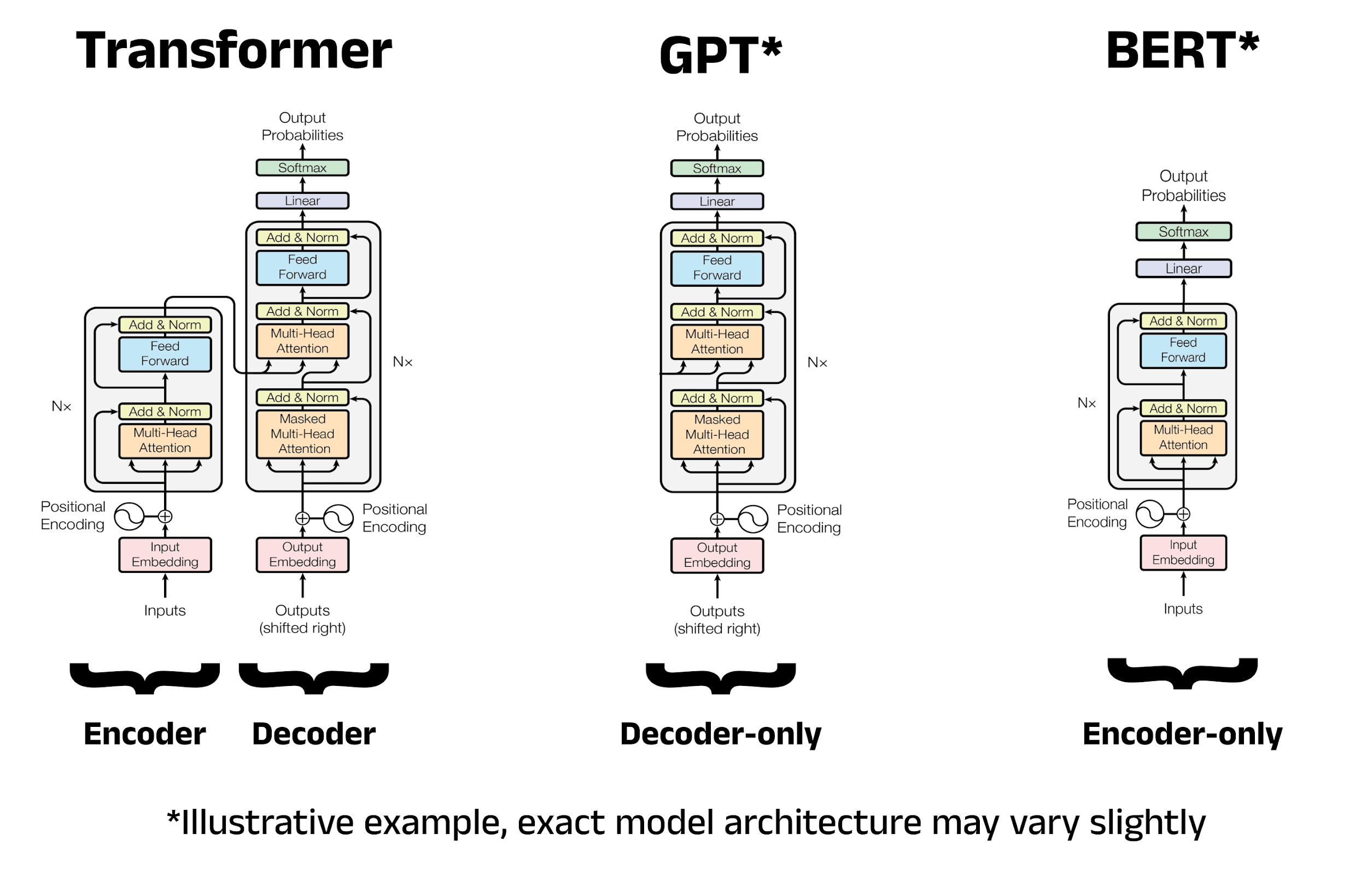

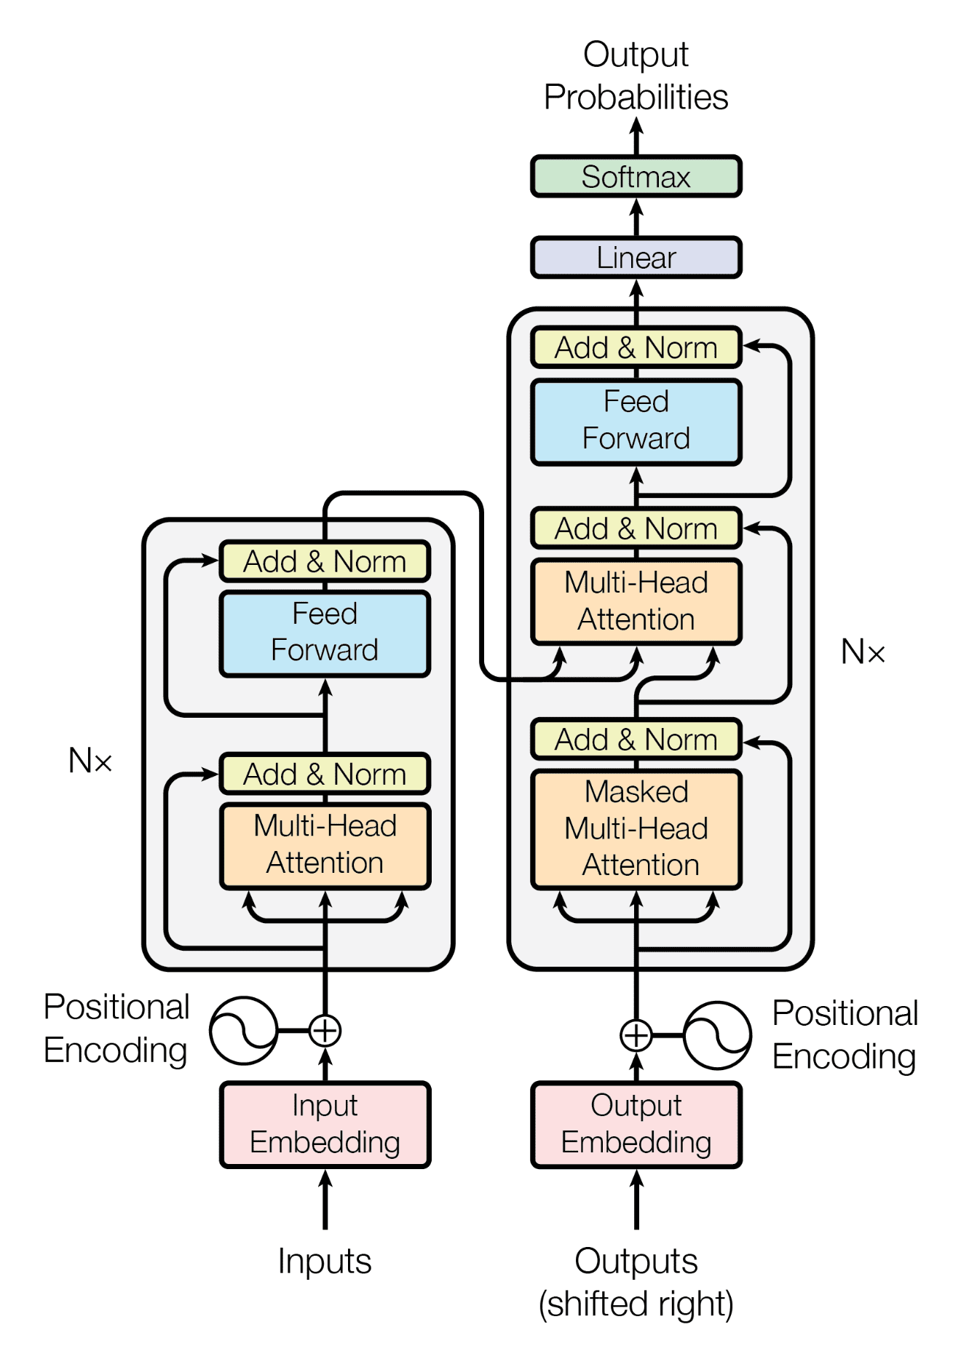

| **Aspect** | **BERT** |
| --- | --- |
| Architecture | Encoder-only |
| Training | Bidirectional |
| Best For | Understanding |
| Output | Contextual embeddings |

### **🔹 Special Training Tasks**

* **Masked Language Modeling (MLM)**
* **Next Sentence Prediction (NSP)**

### **🔹 Use Cases**

* Search ranking
* Sentiment analysis
* Named Entity Recognition
* Question answering

## **3.3 T5 Architecture**

### **🔹 Google T5 (Text-to-Text Transfer Transformer)**

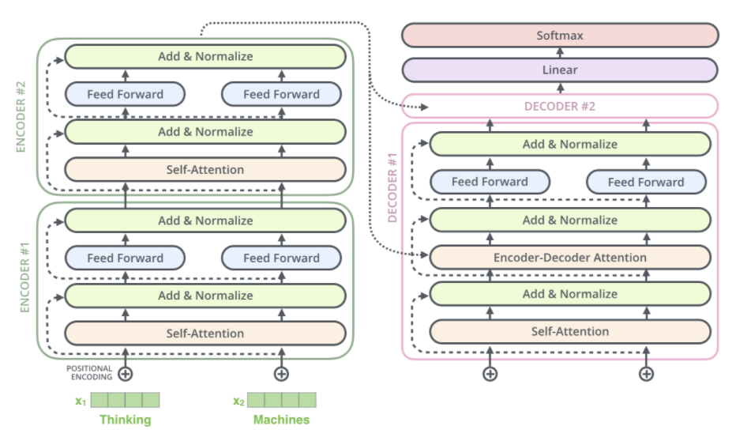

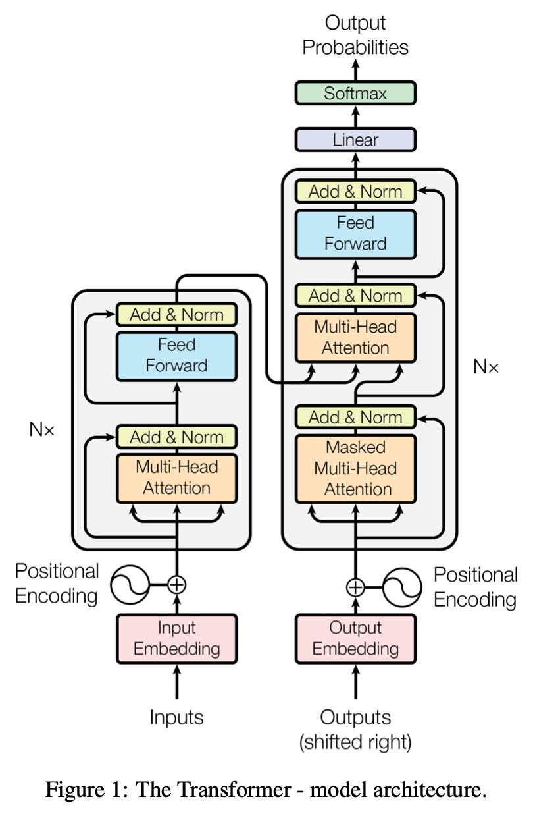

### **🔹 Core Idea**

**Every NLP task = text → text**

Examples:

* Translation → text → text
* Summarization → text → text
* Classification → text → label text

### **🔹 Architecture**

| **Part** | **Role** |
| --- | --- |
| Encoder | Understand input |
| Decoder | Generate output |

## **3.4 PaLM Architecture**

### **🔹 Google PaLM (Pathways Language Model)**

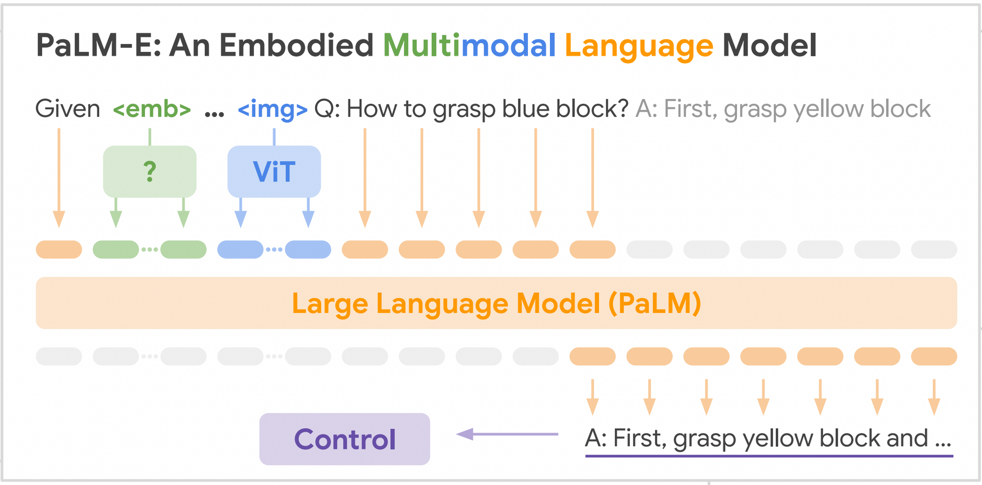

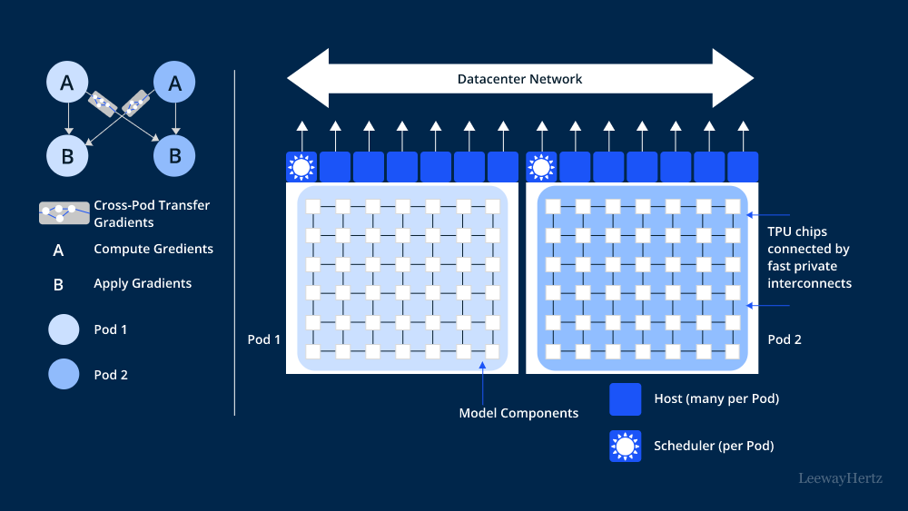

### **🔹 Key Features**

* Massive scale (hundreds of billions)
* Multi-task learning
* Reasoning & math abilities

## **3.5 LLaMA Architecture**

### **🔹 Meta LLaMA**

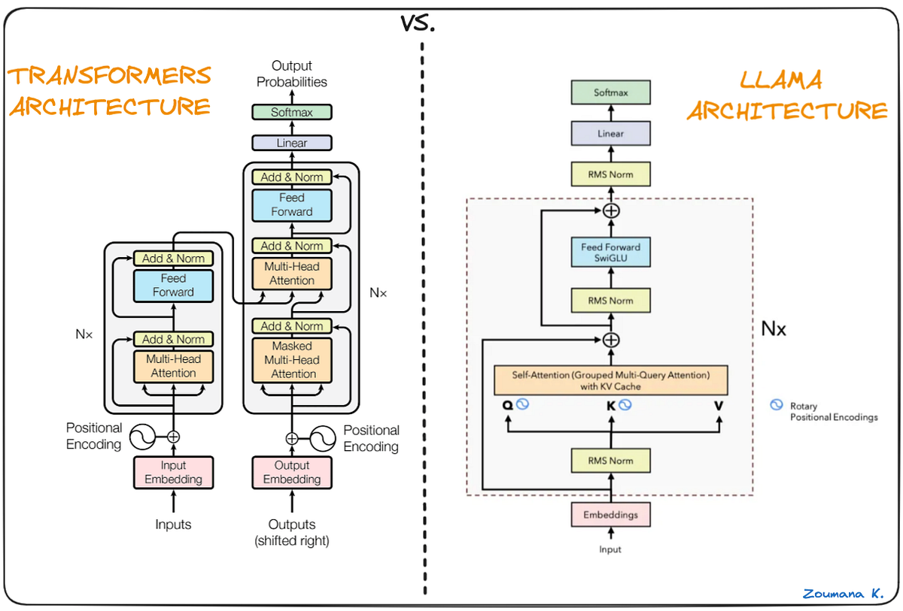

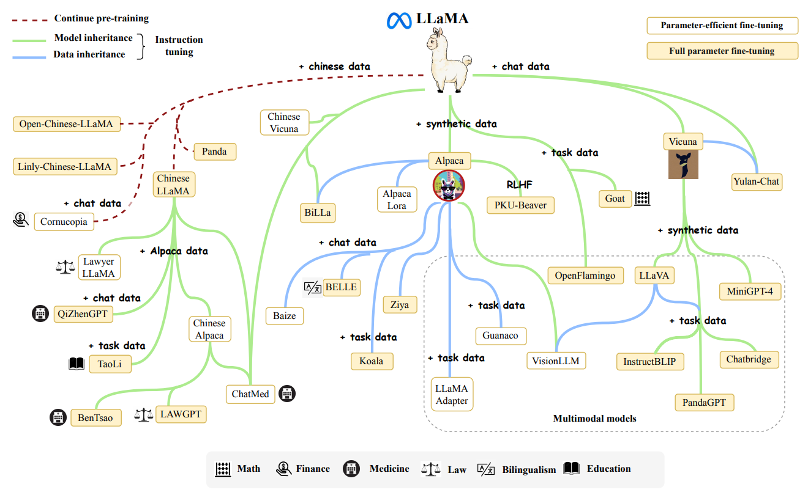

| **Aspect** | **LLaMA** |
| --- | --- |
| Type | Decoder-only |
| Focus | Efficient training |
| Access | Open-source |
| Strength | Runs on smaller GPUs |

### **🔹 Why LLaMA Is Important**

* Democratizes LLM research
* Enables **private & offline LLMs**
* Used in fine-tuning & RAG systems

## **4️⃣ Open-Source vs Proprietary LLMs**

### **🔓 Open-Source LLMs**

Examples:

* LLaMA
* Mistral
* Falcon

**Pros**✔ Free  
✔ Customizable  
✔ Offline usage  
✔ Data privacy

**Cons**❌ Requires setup  
❌ Hardware needed

### **🔒 Proprietary LLMs**

Examples:

* GPT-4
* Gemini
* Claude

**Pros**✔ Best performance  
✔ Easy API usage  
✔ No infra needed

**Cons**❌ Costly  
❌ Data privacy concerns  
❌ Vendor lock-in

## **5️⃣ LLM Lifecycle (End-to-End)**

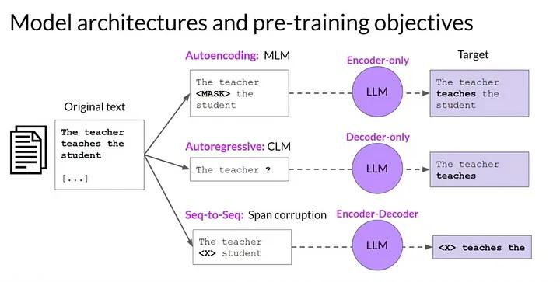

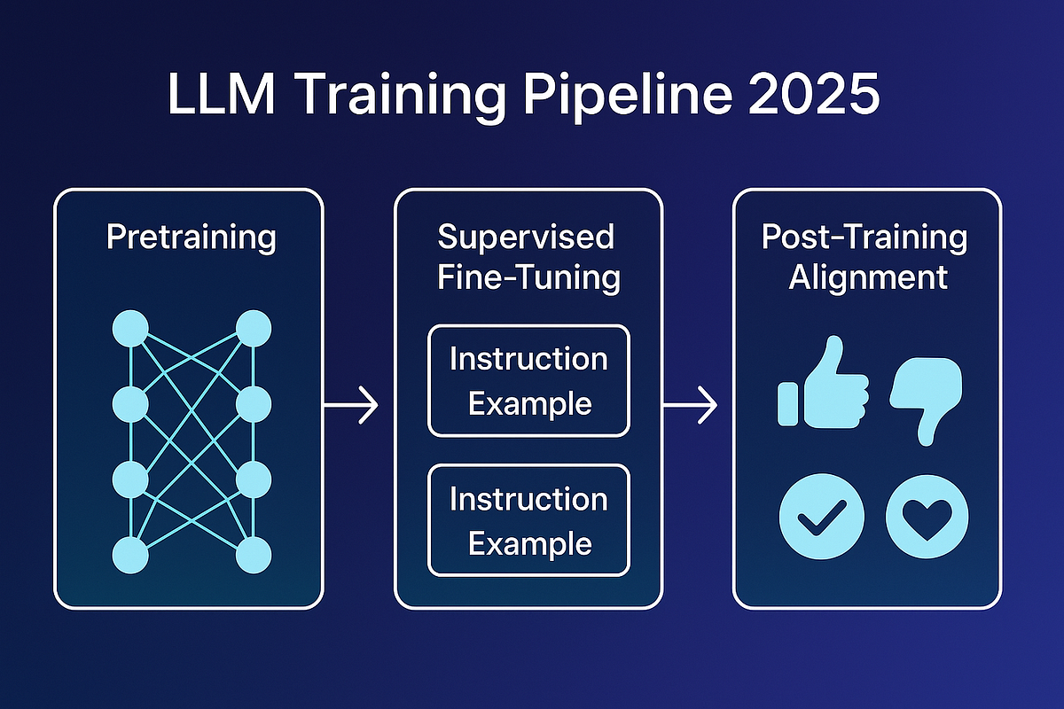

## **🔁 Stage 1: Pretraining**

### **🔹 What Happens?**

* Train on **huge unlabeled text**
* Objective: **next-token prediction**

### **🔹 Output**

A **general-purpose language brain**

## **🔁 Stage 2: Fine-Tuning**

### **🔹 Types**

| **Type** | **Purpose** |
| --- | --- |
| Supervised Fine-Tuning | Task learning |
| Instruction Tuning | Follow commands |
| RLHF | Align with humans |

### **🔹 Example**

Base model → Chatbot model

## **🔁 Stage 3: Inference**

### **🔹 What Is Inference?**

Using the trained model to:

* Generate answers
* Summarize text
* Predict outputs

### **🔹 Key Inference Controls**

* Temperature
* Max tokens
* Top-k / Top-p

## **🧠 Final Mental Model (Remember This)**

**LLMs are probability machines trained at scale using transformers that learn language patterns and generate intelligent responses through pretraining, fine-tuning, and inference.**

## **✅ If You Want Next**

I can:

* Convert this into **PDF / booklet**
* Add **hands-on Python + Hugging Face code**
* Create **teaching slides**
* Build **mini projects (Chatbot, Translator, QA bot)**

Just tell me 👍